The Bellingham Plan
  - Proposed changes to our growth plan
  - November 1, 2024
We heard your input. We’re ready to share our growth strategy. We want to know what you think.

Bellingham is growing. How should we plan for it?
We need to plan intentionally for more housing, jobs, and services.
The Bellingham Plan will guide the city’s growth for the next 20 years. It addresses important topics, such as housing, transportation, and climate resilience, and establishes high-level goals and policies for the city. Those goals and policies will guide development, capital investments, City programs, and other actions across Bellingham as we work toward our vision for 2045.
The current version of our Comprehensive Plan was approved in 2016. State law requires that we update the plan every decade. We are in the middle of the two-year project to update the Comprehensive Plan, with a required due date in 2025.

Growing Need
We must plan for thousands more housing units and jobs by 2045.
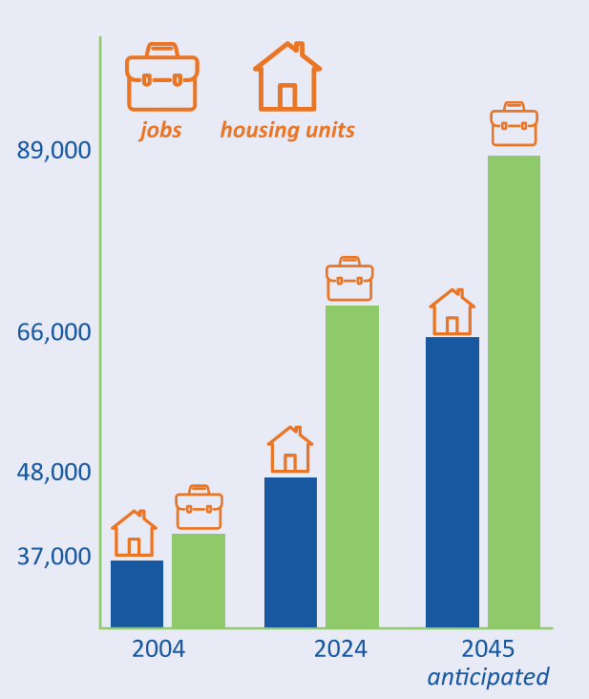

Updates for our 2025 plan
Here, you’ll see the most significant updates we are proposing for Bellingham’s growth plan. The below themes are so broadly important, that many will be found in multiple chapters of the updated plan.
In addition to what you see here, we are making the plan shorter, clearer, easier to use, and more relevant. We are also adding new chapters: Climate, Community Wellbeing, and Equitable and Inclusive Civic Practices.
See our proposed updates for each chapter at EngageBellingham.org
Some things are being updated, but we are also carrying forward these important priorities from previous versions of the plan.
- Balancing urban growth priorities and environmental stewardship
- Compact urban villages with a vibrant mix of housing, jobs, and services
- A range of housing options, especially near transit, jobs, and amenities like parks
- A mix of commercial, institutional, and industrial uses to support a strong local economy
- An arterial network designed for all types of users: cars, bikes, buses and pedestrians
- World-class parks and connecting greenway trail corridors

Proposed Updates

Bellingham for all
What are we proposing?
- Foster stronger community connections.
- Plan inclusively and equitably across the city, with less focus on neighborhood-specific planning.
- Work with partners to shape Bellingham’s role in regional job growth.
- Increase the City’s efficiency and responsiveness with a coordinated, cross-functional, “One City” approach.
The community said...
- All areas of the city need to be part of equitable change.
- Cultural differences should be celebrated and seen as a strength.
- People of all ages should feel supported, especially seniors and youth.
- People should feel connected to their community and have opportunities to gather.

More Housing Choice
What are we proposing?
- Support increased housing development by allowing more “middle” housing types across the city – up to four middle-housing style homes per lot, such as in a fourplex or as townhomes.
- Allow bigger buildings and more housing types along transit corridors.
- Make it easier to build housing, such as with clear, predictable design standards.
- Encourage mixed-income housing developments with affordable housing incentives.
The community said...
- Neighborhoods across the city should have choices for everyone, with a variety of housing types and places to gather and shop nearby.
- Housing affordability should be in alignment with local wages.
- We should have enough housing that it’s easy to find options that suit everyone’s needs.
- Human-scale streetscapes make it pleasant to get around the city.

Sustainable Growth
What are we proposing?
- Plan a network of vibrant, urban clusters that are connected by well-designed transit corridors with multimodal transportation options for all.
- Keep investing in urban villages.
- Allow small-scale businesses, like childcare or cafes, in all residential areas.
- Adjust what areas the city could grow into.
- Plan intentionally for long-term infrastructure.
The community said...
- Transit connects our Urban Villages with frequent service.
- People have safe options for getting around, especially on foot or by bike.
- Utilities and services have expanded to meet our growth.

Climate Resilience
What are we proposing?
- Introduce a new chapter focused on climate work, while also linking and integrating climate topics throughout the plan.
- Continue climate mitigation work to lower our community’s greenhouse gas emissions over time.
- Foster climate resiliency, readying our community for a changing climate and more frequent climate events.
- Support more transportation connections to provide more choice and limit congestion and emissions.
The community said...
- The community should integrate consideration for climate change into our habits and choices.
- The City should serve as a leader in shifting toward a more sustainable and resilient future.

Where did ideas for these updates come from?
Updates are based on a combination of Washington State requirements and community feedback.
Do the proposed updates match what you want to see?
Provide your feedback on our proposals for the key themes from the previous pages.
Dive into overviews of each chapter in the plan, and provide feedback on the updates we’re proposing for each individual chapter.
RSVP for one of three open houses we will host in November, where you can provide feedback and chat with us about these changes.
Tell us what you think at EngageBellingham.org

Now is the time to provide feedback.
We’ve spent the past year getting input from the community and developing a growth strategy based on what we heard and changes required by state laws. Now, we’re ready to hear your thoughts on our ideas. In mid-2025, we will have more detailed draft chapters to share and get your feedback on before we move on to Phase 4: Legislative Adoption.

2023-24
- Phases 1 & 2
- Community engagement
- 15 public events - in person and online
- ~850 event visits
- ~1,400 people engaging online

Late 2024-Current Phase
- Phase 3
- Draft Review
- Public review of proposed updates
- Public open houses and online feedback
- Incorporation of feedback into plan

Mid-2025
- Phase 4
- Legislative Adoption
- Bellingham Planning Commission review
- Planning Commission gives recommendation
- Bellingham City Council adoption

June 2026
- Deadline to Finalize
- Code Update
- Update our code per state housing legislation

