

City of Bellingham
Tourism Grant Program
ELIGIBLE EXPENSES & MARKETING REQUIREMENTS

Eligible operational expenses are limited to venue rentals (i.e. conference rooms), equipment rentals (i.e., cones, traffic signs, etc.), a portion of rent (must be proportionate to the event), and/or the purchase of goods/supplies with prior approval by the City. For example, payroll, travel, alcohol and equipment expenses are NOT allowed. Final decisions by the City on allowed operational expenses will be identified in the contract, and all expenses must be incurred and paid during the contractual period with appropriate back-up documentation available. For events or projects occurring early in the calendar year, marketing expenses incurred within the previous year may be eligible for reimbursement provided they are included in the budget.
Marketing Requirements:
As revised by the Washington State Legislature and effective June 30, 2013, RCW 67.28.080 defines a tourist as people travelling:
- For business or pleasure staying overnight in paid accommodations,
- To a place 50 miles or more one way from their place of residence or business or
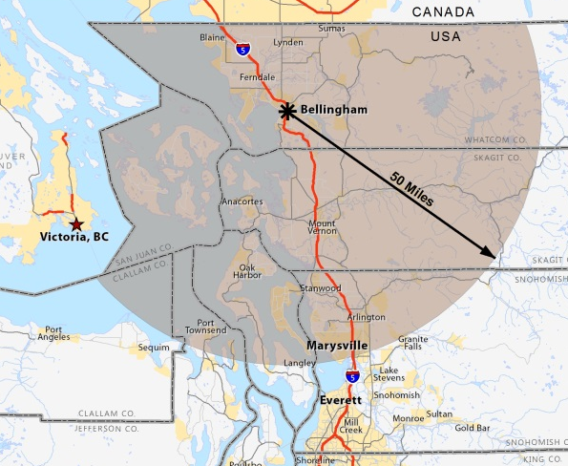
- From another country or state outside of their place of residence or their business.
For purposes of this grant program, funding is limited to promotional activities which draw tourists, as defined above, to Bellingham.
Important clarification on eligible expenses for marketing: An eligible publication may distribute within the 50-mile boundary provided they also distribute outside of this boundary. For example, Adventures Northwest Magazine distributes within the boundary but also distributes east of the mountains, in King County, Portland and into Canada.
The City will require a distribution list from the publication and will pro-rate reimbursement based upon amount distributed outside of the 50 miles. Applicants are encouraged to contact staff for a determination of eligibility.

